**Coding Assessment Spark**

**Name : Jeevan Sai Badana**

**Mail:** [jeevansai100@gmail.com](mailto:jeevansai100@gmail.com)

DATE: 12-02-2024

Question number 1

**1.Execute Manipulating, Droping, Sorting, Aggregations, Joining, GroupeBy DataFrames**

First we import SparkSessions as shown in below

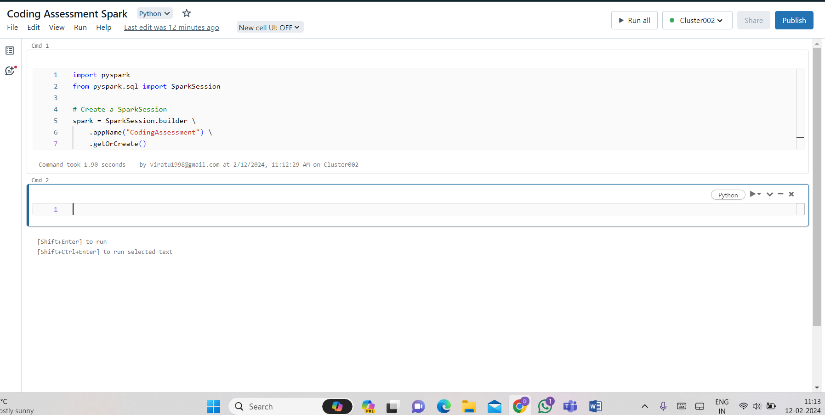

Create sample DataFrames and show the data in it

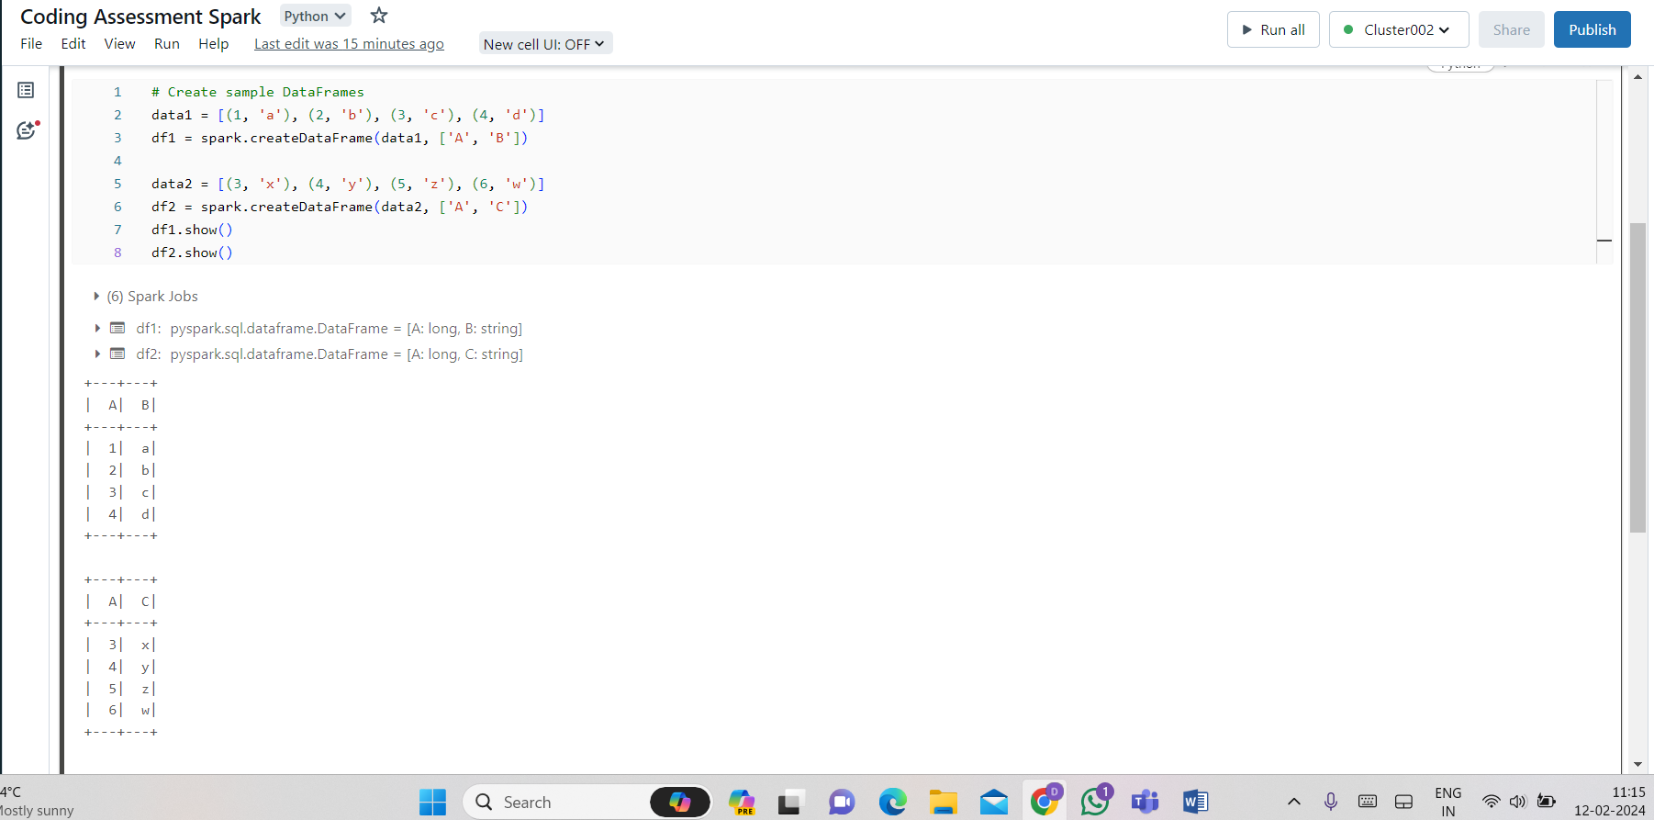

Manipulating DataFrame:

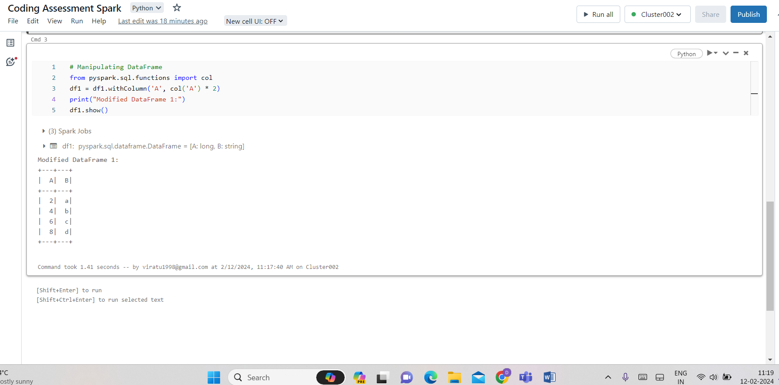

Dropping columns:

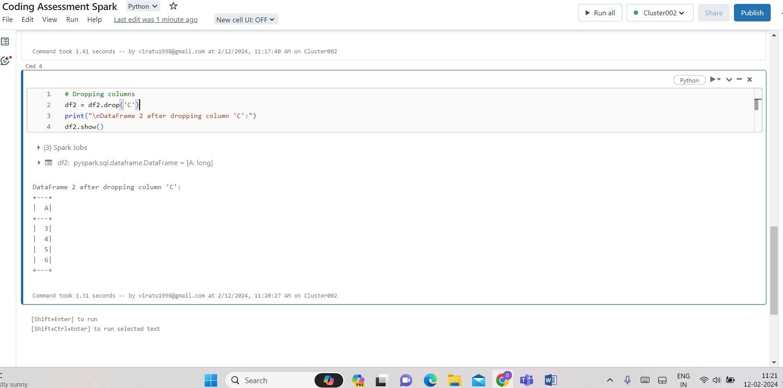

Sorting:

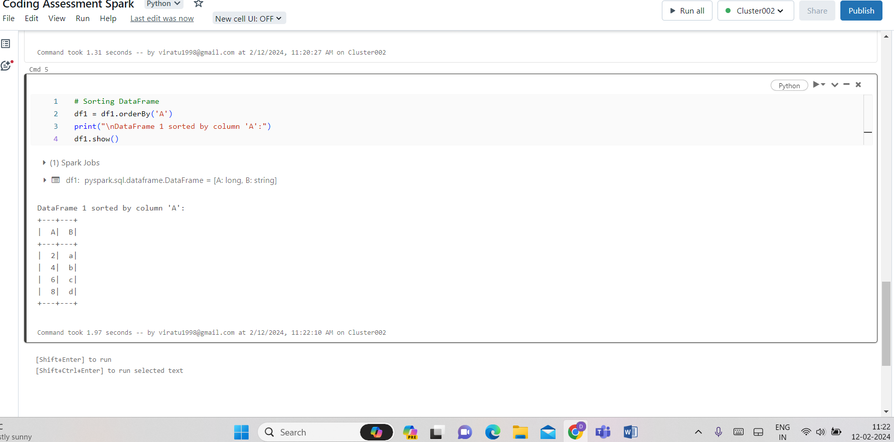

Sorting DataFrame in descending order:

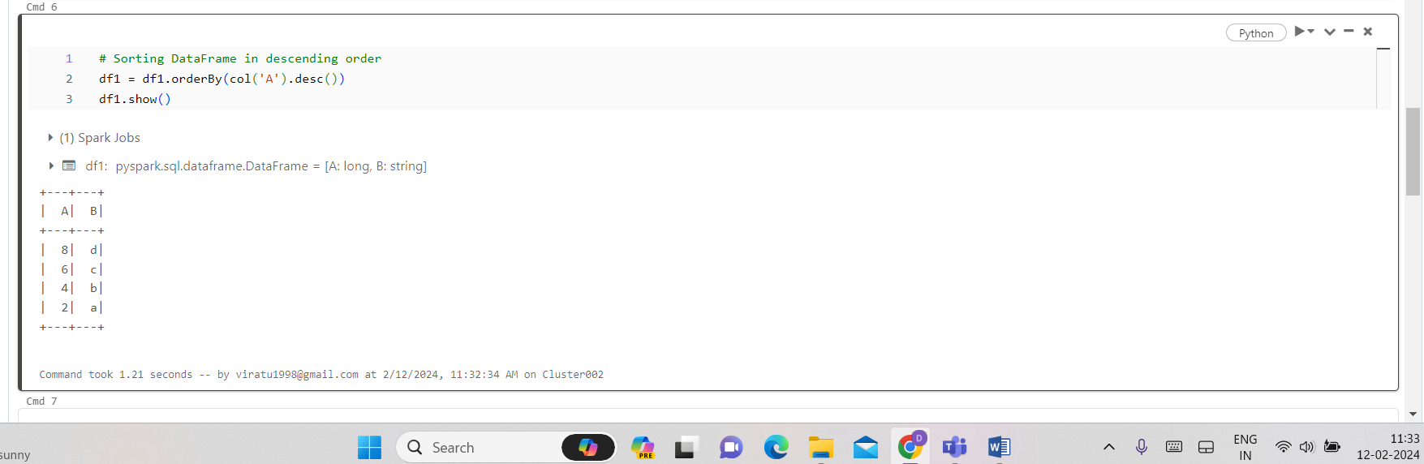

Aggregations Avg or mean:

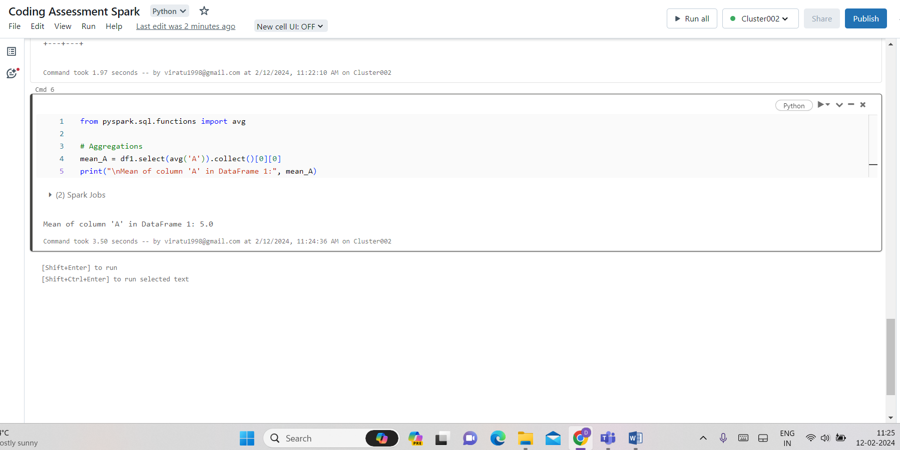

Joining DataFrames:

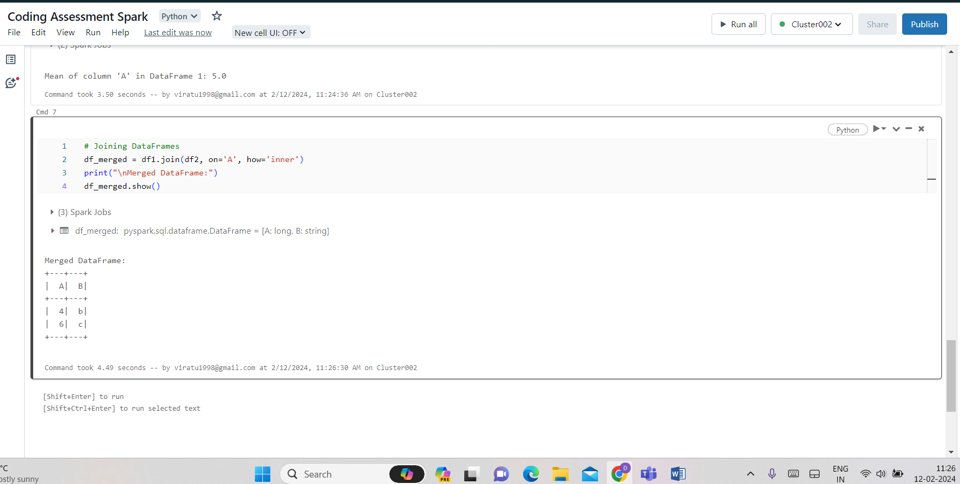

Grouping by DataFrame:

